**EXPERIMENT - 10**

**AIM**: To explore BiGG Model

**URL-** <http://bigg.ucsd.edu/>

**Theory-** BiGG Models is a knowledgebase of genome-scale metabolic network reconstructions.

BiGG Models integrates more than 70 published genome-scale metabolic networks into a single database with a set of standardized identifiers called BiGG IDs. Genes in the BiGG models are mapped to NCBI genome annotations, and metabolites are linked to many external databases (KEGG, PubChem, and many more). For details about updates to the BiGG Models website and database, see the updates page and the GitHub repository.

BiGG is freely available for non-commercial use. It is hosted and maintained by the Systems Biology Research Group at the University of California, San Diego.

**PROCEDURE-**

1. In the search box, search for the interested organism or pathway or model.

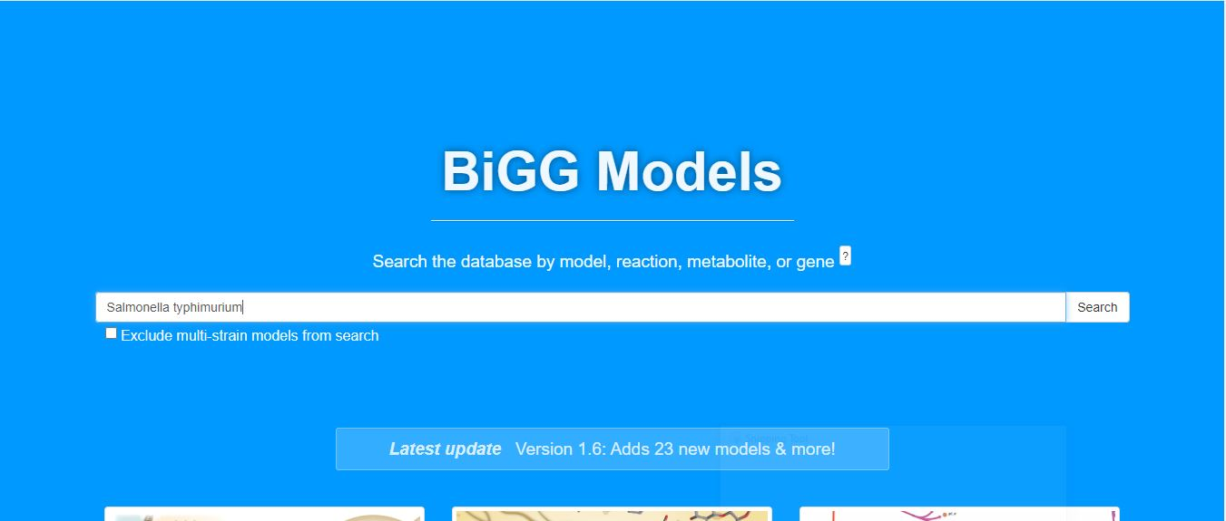

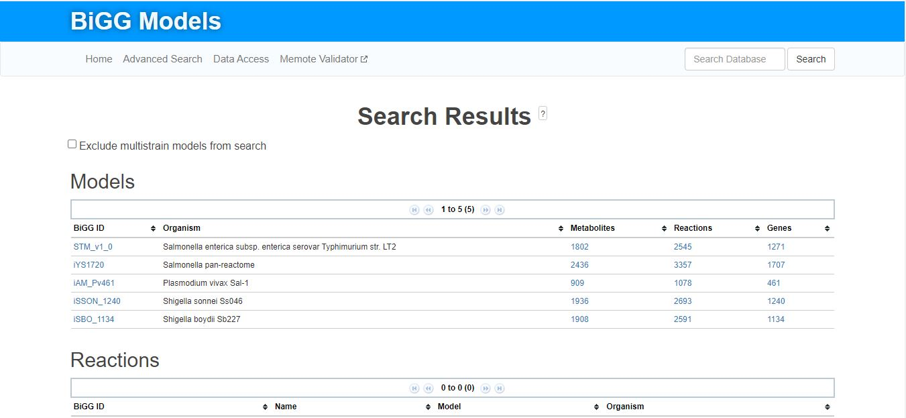2. From here, choose the interested model or metabolite or reaction you want to explore related to selected organism.

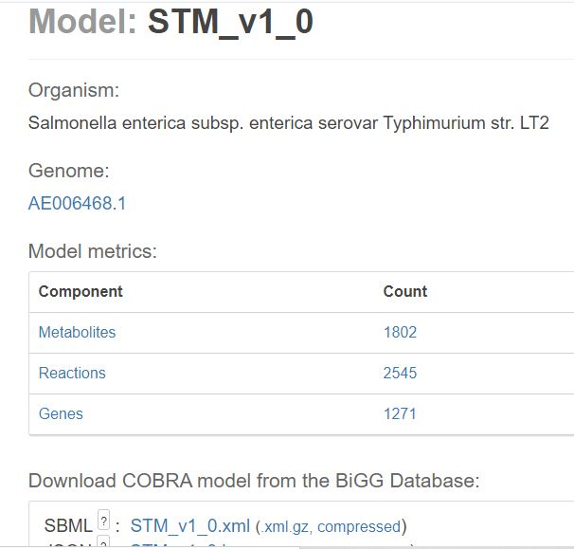

3.From here, we can retrieve the information we require , for example the

* Genes
* Metabolites
* Reactions

**3.1 Genes:**

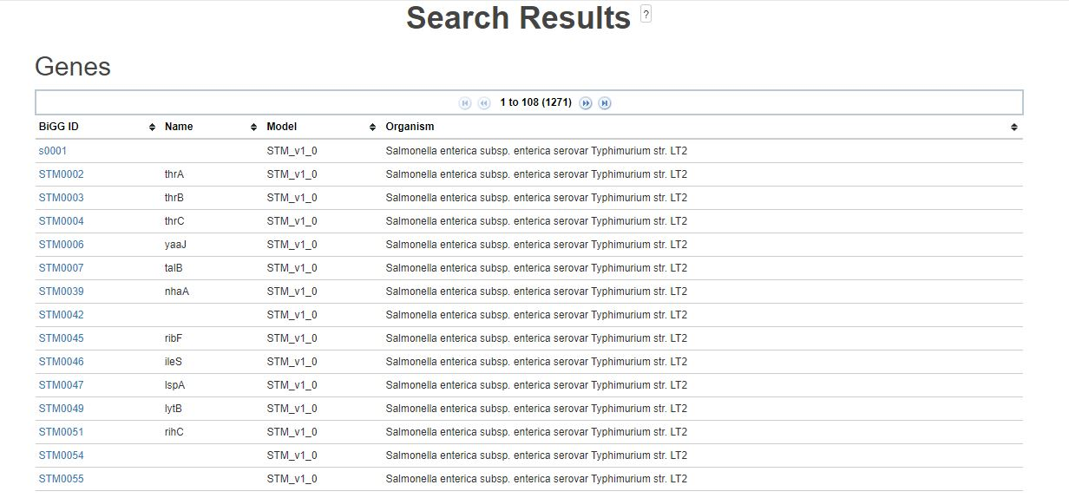

**3.2 Metabolites:**

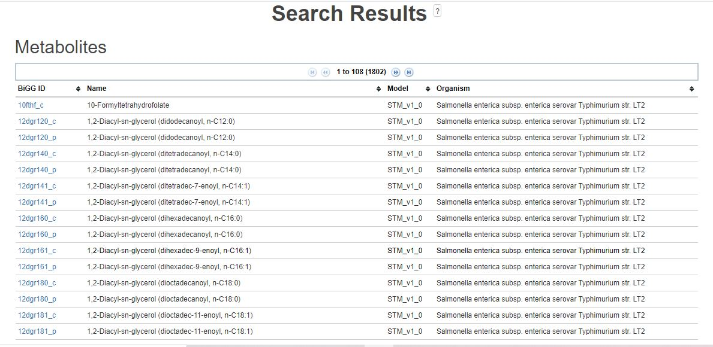

**3.3 Reactions:**

